Airplane Servo Controller
Abstract

My Airplane Servo Controller project is a product of necessity as most good designs are. I’ve been building and flying model aircraft for a number of years, and setting up control surface throws has always been a stumbling block for me. For those who don’t know about aircraft, they are controlled by “control surfaces” that move in one direction or the other and change the way that the air flows by the plane. This causes the plane to change direction in a certain way.
Depending on the design of the aircraft, the amount that the control surface should move may be different. Therefore, when setting up a new aircraft, it is important to measure and adjust the throw of the control surfaces to make sure they are within the design specifications. The reason that this can be difficult is because the control sticks on the radio transmitter are spring-loaded and therefore require one hand to be holding them while the other tries to measure the aircraft. I decided that it would be much easier if I could have both hands available to do the measurements. An airplane servo controller needed to be build that could meet three requirements:
- The aircraft transmitter should not be needed
- Servos should be able to be set to any position and held there
- The positions of the servos should be shown (in % full travel) to aid in setting up computer radios (i.e. Dual-Rate functions)
With ample GPIO, an internal oscillator, and an easy programming
interface, the Atmel ATmege16 was a good microcontroller to build around. Its outputs could directly drive the control signals of the aircraft servos while still leaving plenty of I/O for reading push buttons and interfacing with an LCD display. Running at 8 MHz, there was plenty of horsepower to service waveform ISRs while still maintaining a responsive user interface.
Below, you can see an overview of the basic components, a complete schematic, a picture of the completed prototype, as well as a snippet of code.
All source code was edited using Programmers Notepad and was compiled using avr-gcc. The code that is shown is the ISRs that controlled the timing of the waveforms that operated the servos.
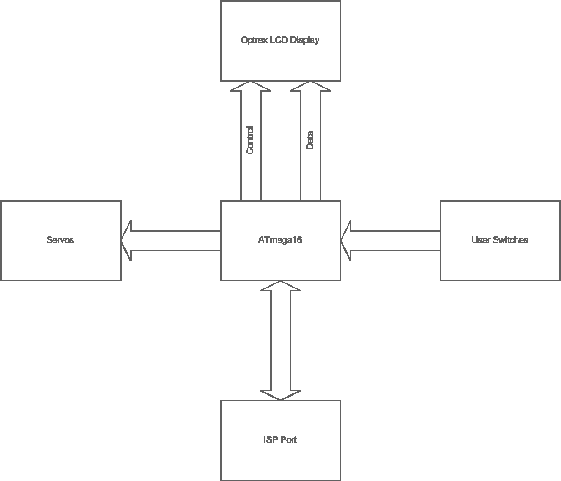
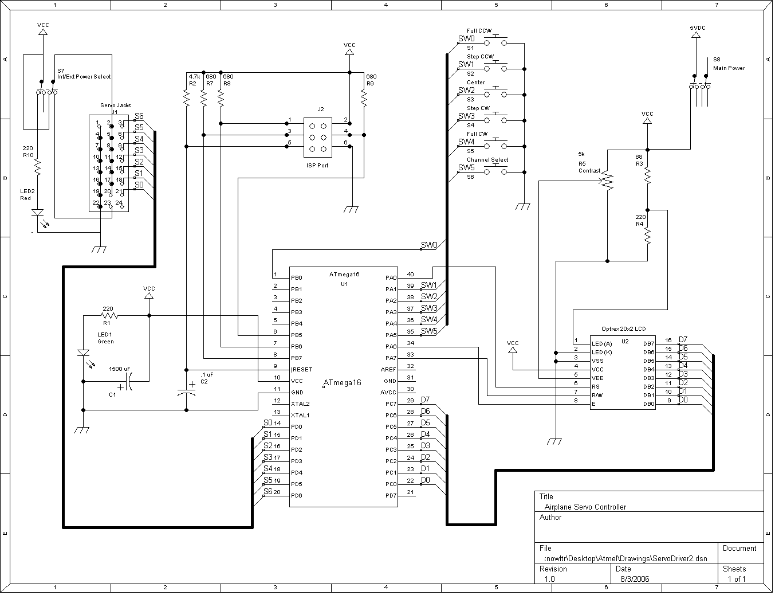

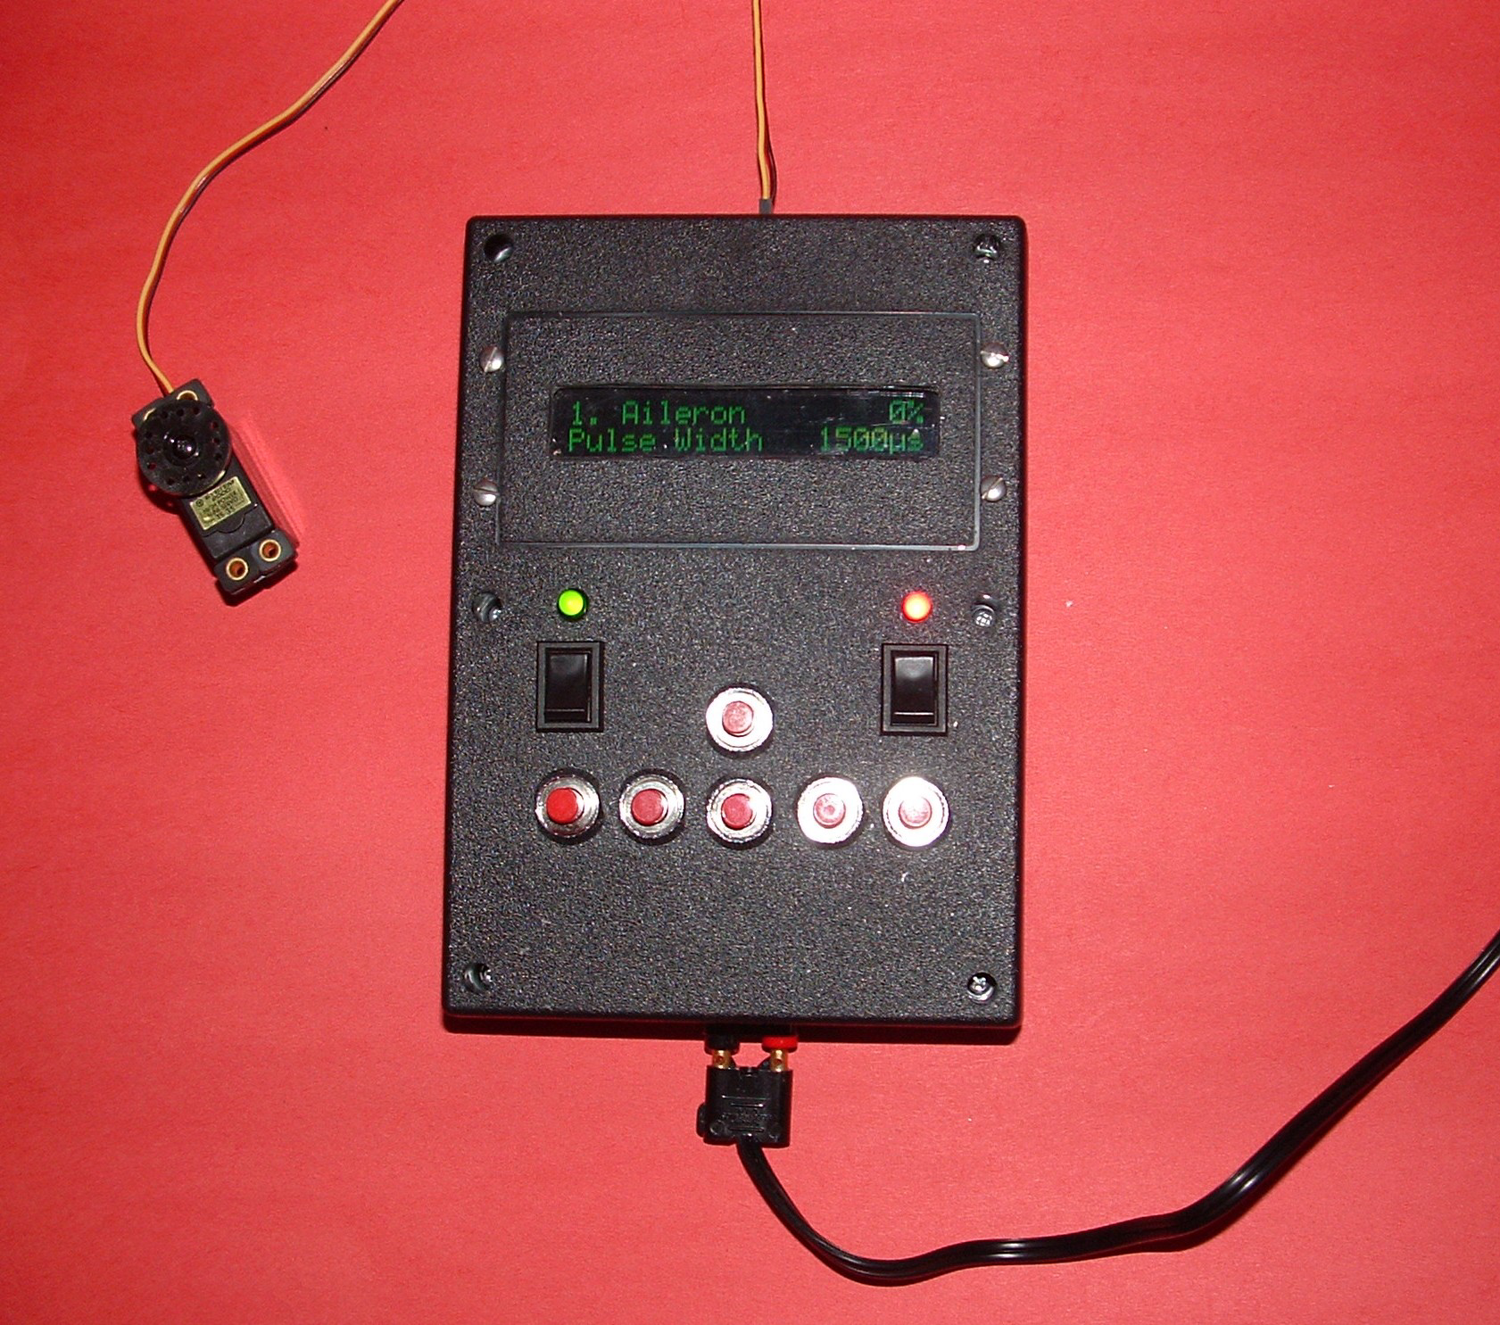
ISR(TIMER0_COMP_vect)
{
int i;

//Calculate pulse timer count values
for(i=0; i<NUM_SERVOS; ++i)
{
ServoTimer[i] = (((ServoPos[i]-1000.0)/1000.0) * 125.0) + 125.0;
}

//Start an update on all channels
TCCR2 = (1<<WGM21) | (1<<CS22); //Enable TIMER2 w/ clk/64 prescaler

//Update counters for other timing functions
++LCDUpdateTics;
++ChannelChangeWaitTics;
++StepWaitTics;
}

ISR(TIMER2_COMP_vect)
{
static int ServoNum;

PORTD = 0; //Turn OFF all outputs

//Did we just turn off the last channel?
if(ServoNum == NUM_SERVOS)
{
TCCR2 = 0;
ServoNum = 0;
return;
}

//Start pulse on next channel
PORTD = (1<<ServoNum); //Turn ON output for this channel
OCR2 = ServoTimer[ServoNum]; //Set timer for pulse width

//Get ready for next channel
++ServoNum;
}

